**While aid to Northern Triangle countries shows an increase over the decade, aid to Peace Corps declines**

**By Dwight A. Weingarten**

WASHINGTON – While there has been a net increase in the overall aid to the Northern Triangle countries of Guatemala, El Salvador, and Honduras over the past decade, aid to the Peace Corps in the region has declined precipitously after the organization withdrew from two countries.

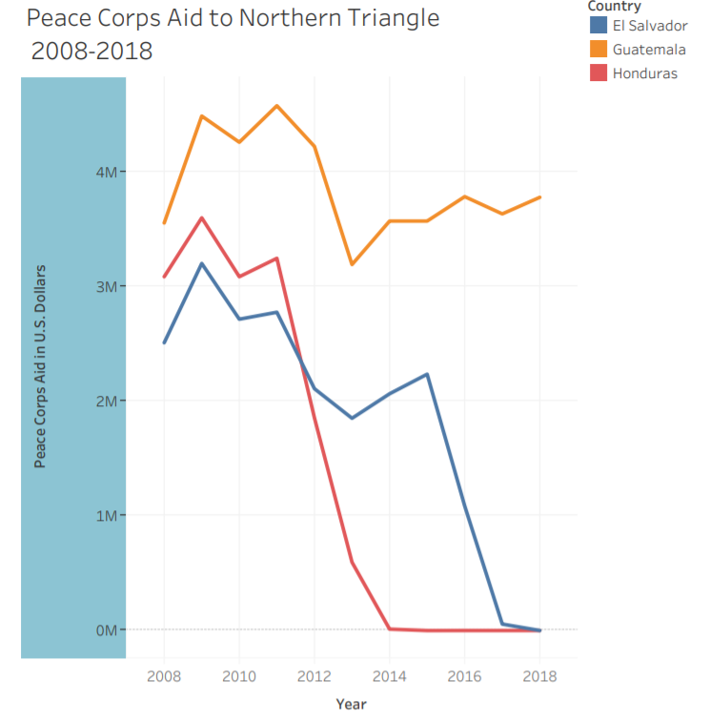The Peace Corps was suspended in Honduras in 2012 and El Salvador in 2016 due to the security environment in the two countries, a Peace Corps spokesperson said in an email, but the lack of human capital in the region and cross-cultural connections could have long-term effects.

“The value of added of the Peace Corps is the cultural immersion,” said María Fernanda Pérez Arguello, the associate director at the Atlantic Council’s Adrienne Arsht Latin America Center.

|  |
| --- |
| **President John F. Kennedy established the Peace Corps in 1961 to** [**accomplish three main goals**](https://www.jfklibrary.org/learn/about-jfk/jfk-in-history/peace-corps)**:**   * **To help the people of interested countries and areas in meeting their needs for trained workers.** * **To help promote a better understanding of Americans on the part of the peoples served.** * **To help promote a better understanding of other peoples on the part of Americans.** |

“It really helps if people live down there and that they come back, it helps them put things in perspective of just the conditions in these countries,” said Fernanda Pérez Arguello.

While the Peace Corps aid to the region has declined, total aid to the region is declining as well during the current administration.

“Cutting off direct assistance to those nations for judicial reform, anti-gang initiatives and infrastructure is counterproductive to say the least,” said Sen. Dianne Feinstein, D-Calif., after President Donald Trump announced he would cut off direct aid to the Northern Triangle in late March.

“It will likely lead to more violence and even more emigration, not less,” Feinstein [said in a statement](https://www.feinstein.senate.gov/public/index.cfm/press-releases?ID=0F09DF71-1B57-44A5-B7C8-A74364C0E4C5).

Financial aid to the Northern Triangle spiked after the unaccompanied child crisis of 2014 in order to address the flow of migration to the U.S. border, but overall aid has declined since 2017 while President Trump has been in office.

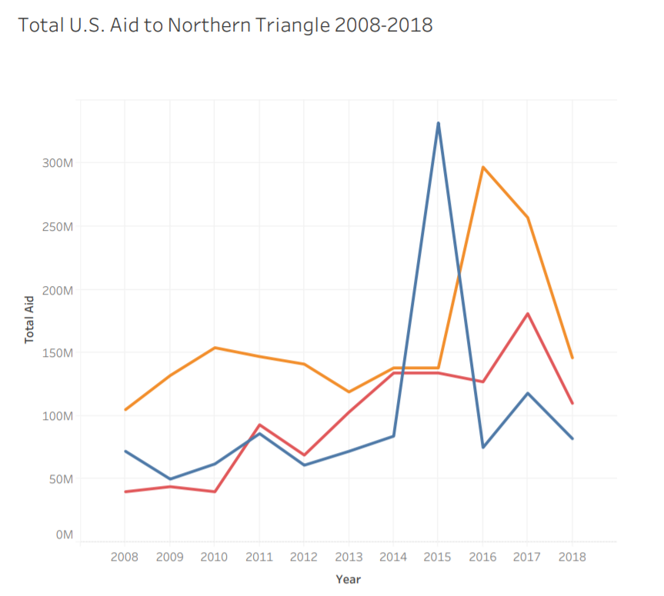“We were paying [Guatemala, Honduras, El Salvador] tremendous amounts of money,” said President Trump [in March](https://publicpool.kinja.com/subject-remarks-by-president-trump-during-a-visit-to-l-1833679944). “We’re not paying them anymore because they haven’t done a thing for us,” he said.

Michelle Mittelstadt, a spokesperson for the Migration Policy Institute, a Washington-based think tank that studies migration, said economic conditions are just one of a number of push factors driving this emigration.

“The linkages between development and migration are complex,” said Mittelstadt. “There is [significant evidence](https://www.migrationpolicy.org/research/moving-beyond-root-causes-complicated-relationship-between-development-and-migration)) around the world that in fact development assistance actually increases migration over the near term.”

Mittelstadt adds though that losing hundreds of millions of dollars in development assistance is not a positive factor in ending migration flows.

“We tend to think only about the money, but not about the implications of cutting aid,” said Fernanda Pérez Arguello. “It’s not only about the dollars and the money, it’s also about influence and alliances,” mentioning that aid also includes training and technical assistance like what the Peace Corps has provided over the years.

The Peace Corps was established in El Salvador in 1962 and operations began the next year in Guatemala and Honduras, with American volunteers carrying out what a Peace Corps spokesperson called “people-to-people public service and citizen diplomacy.”

“[Volunteers] become immersed in their host communities,” said the organization’s spokesperson, “focusing on sustainable projects designed to improve the quality of life and strengthen local economies.”

Since the Peace Corps’ establishment, nearly 13,000 Americans have served in the region on projects to improve health, food security, water sanitation, and youth development, but at present only 136 volunteers are working in the region --with all of the volunteers working from Guatemala.

One of the thousands of volunteers who served in the region is Jean Waagbo, who worked in Honduras from 1980 to 1982 at a primary school, assisting with agriculture and nutrition.

Waagbo saw the impact of Peace Corps volunteers being on the ground during her time there. If the community needed something, Waagbo said, I could very simply access USAID funding for food or tools for them.

“Aid helps the United States create alliances, partnerships in countries,” said Fernanda Pérez Arguello. “By cutting this aid, the United States is leaving a vacuum in the region,” she said.

Fernanda Pérez Arguello says China is eager and ready to fill that vacuum.

In addition to the international power dynamics, something more personal is at stake – the connections between citizens.

“Volunteers also develop friendships that last a lifetime and promote a better understanding of Americans in the countries where they serve,” said a Peace Corps spokesperson.

The experience “marked me for the rest of my life,” said Waagbo, who has as an adult worked for non-profits in the region.

Waagbo said she has spent her life sharing with people in the U.S. about her experience in Honduras, including returning to give presentations at her high school alma mater.

While the personal impacts of such experiences are immeasurable, even when the Peace Corps operated in all three countries, the percent of aid that went to the Peace Corps out of total aid was just 4 percent or $41 million dollars over the four year period.

“Aid is not charity,” said Fernanda Pérez Arguello. And for such a small percent of the federal budget, said Fernanda Pérez Arguello, these investments are worth it.

Every dollar given is in the U.S. national interests, for national security, Fernanda Pérez Arguello said.

With the military support that was stationed in Honduras during her time in the Peace Corps, Waagbo said she felt relatively safe.

But Waagbo said the costs today would be immense in order to protect the volunteers from gang violence. The Peace Corps considers the costs of security for the volunteers too great at present.

“The agency would welcome the resumption of programming in either Honduras or El Salvador, following an invitation from the host government and a favorable assessment,” said a Peace Corps spokesperson.

What’s lost is in the meantime while aid funding declines and the Peace Corps presence in the region minute is a substantial group of Americans who understand the on-the-ground realities and are working for change in the region.

As for Waagbo, the experience changed her.

“Going in, I had the stereotype that poor people didn’t advance because they were lazy, possibly stupid,” Waagbo said. To see the people’s desire to learn amidst the most difficult conditions stayed with me for the rest of my life, she said.

As for the community in Honduras, Waagbo helped change it.

Waagbo said because of her status, the Honduran Minister of Education signed the paperwork for her to open a secondary school in the village. The [Instituto Lamani](https://www.reditac.hn/index.php/institutos/comayagua/inst-lamani) opened with 12 students that worked in the agricultural fields during the day and attended evening classes.

Twenty years later, in the area on a work trip, Waagbo returned to the village and stood in the classroom with students who were not yet born when the school was founded.

“The founding Principal and I looked each other in the eyes and cried,” said Waagbo in an email, “After 20 short years our dream at been realized! The Instituto was here to stay.”

In the years to come, if the budget for aid in the Northern Triangle continues to shrink and the presence of “citizen diplomats” continues to decline, the test will be if the good will inspired by Americans, towards Americans will be “here to stay,” or not.